
National Concert Hall Visual Guide,
Soundscapes, 25th March, The John Field Room
This is a visual guide for people coming to the National Concert Hall (NCH). It will tell you how to get to the NCH and what you can find. This is a working document, so please let us know if there is something you would like us to include.
If any of this is confusing or you want us to include additional information in this document, you can email our box office team at info@nch.ie, and they can answer any questions you have about the building.

Soundscapes is a neuroaffirmative show.
Everyone is welcome to make noises, move around the space, dance, leave and come back as they wish. Everyone is also welcome to actively participate in the show, or simply listen, as they wish. Please do not feel the need to shush people, ask them to be still or pressure them in any way to participate.
We have a few rules to keep everyone safe which are :
- Audience members are not allowed on stage or to touch the instruments which are on stage. Our lead performer Ríona will bring some instruments and props into the audience which they will be welcome to touch and try out like the thumb piano (more info below).
- Please no running in the John Field Room.
- You are welcome to take photos of your own group but please do not take any photos of any other audience members and please do not share photos online [check this is accutae with NCH]
There is access to the foyer up to an hour before the show begins.
The performance of Soundscapes will take place in The John Field Room.
There will be ear defenders available for anyone who wishes to use them.
There are also a number of small tents in the John Field Room and the foyer. Everyone is welcome to use the tents at any point during the show.
If at any point during the performance you need any assistance you can ask our support staff.

- Getting here
- When you arrive
- Bathrooms
- The John Field Room
- Soundscapes
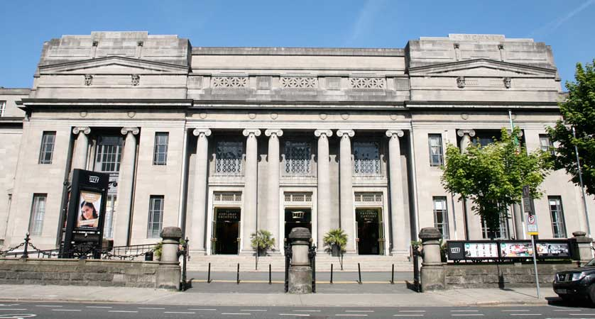 | Welcome to the National Concert Hall. Lots of different music events happen here.  There are 5 steps up, and a ramp to access the building.

Getting Here
We are located on Earlsfort Terrace in the heart of Dublin's City Centre. There are many convenient ways to get here throughout the week and over the weekend.
View our Location on Google Maps

Dublin Bus | Number 44 (from DCU to Enniskerry); and number 61 (from Eden Quay to Whitechurch) all stop on Earlsfort Terrace, directly outside the NCH.  Number 46a (From Phoenix Park to Dun Laoghaire) stops on Leeson Street, beside Earlsfort Terrace.
Luas | Take the Luas to Harcourt, and make your way to Earlsfort Terrace via Hatch Street.
The Scenic Route | If you're coming to an afternoon concert, popping into us for lunch or just visiting during the day, why not take a stroll through the beautiful Iveagh Gardens, located just off Harcourt Street. You can access the NCH through an exit just a few minutes from the Clonmel Street entrance. The exit is located beside the statue of tenor John McCormack.
DART | Our nearest DART station is Pearse Station.

When you arrive:

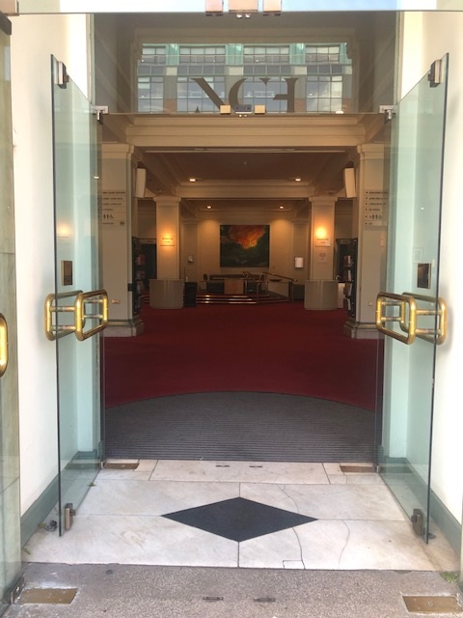 | Come through our front doors into our main foyer space.
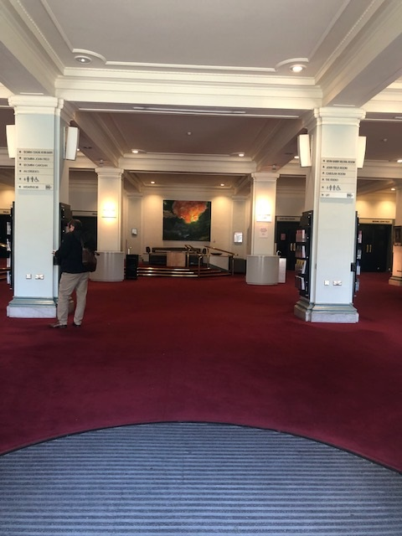 | Just inside the main doors.  There might be lots of people and lots of noise in the foyer.
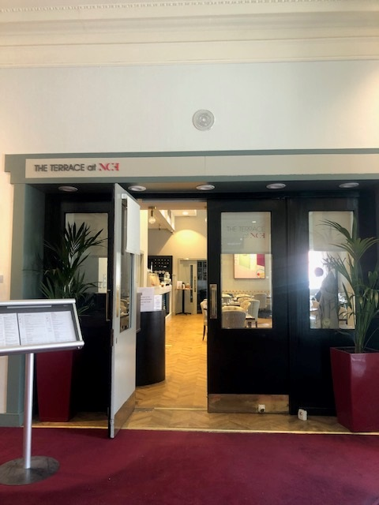 |  | When you turn to your right you will see our Café.  You can buy food and drinks here.  There might be lots of people and lots of noise.
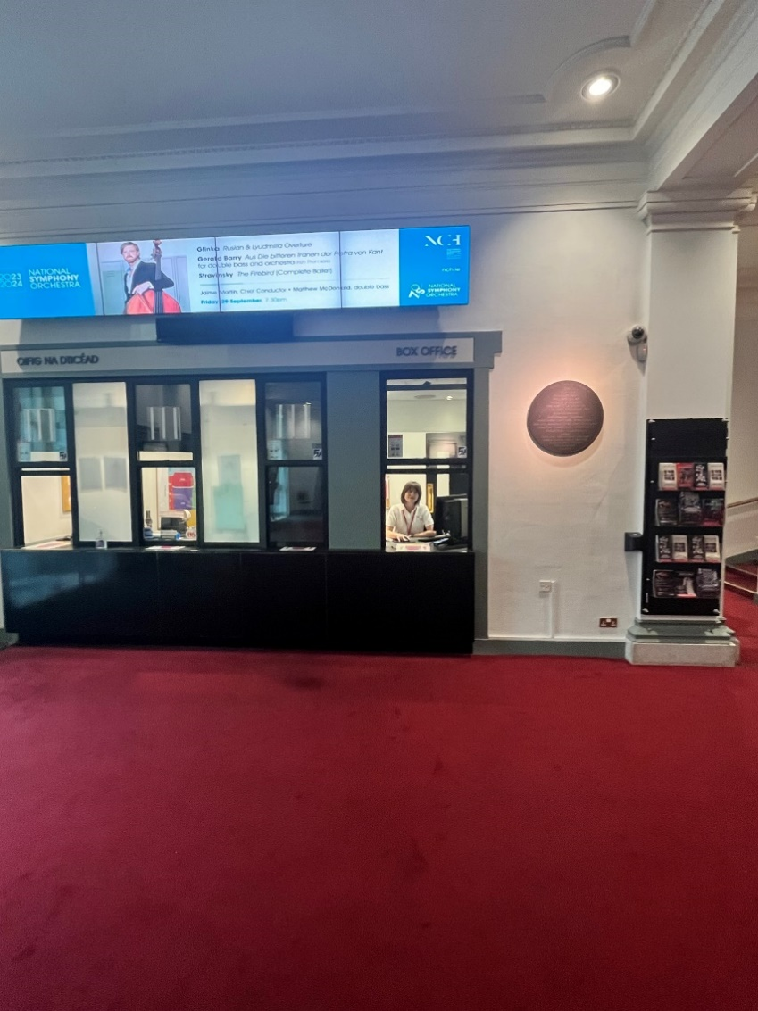 |  | If you look to your left, you will see our box office.  The people here will print off your tickets if you don’t have them on your phone/tablet, and also can tell you about any up-coming concerts you are interested in or would like to book for.
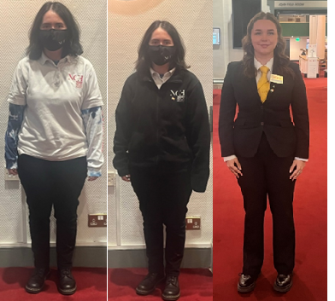 |  | Our staff have a few different uniforms, and sometimes they wear masks.  If you have any questions, please find anybody in one of these uniforms and they will help you.

Bathrooms:
 | On the ground floor there are men’s, women’s and gender-neutral accessible toilets.
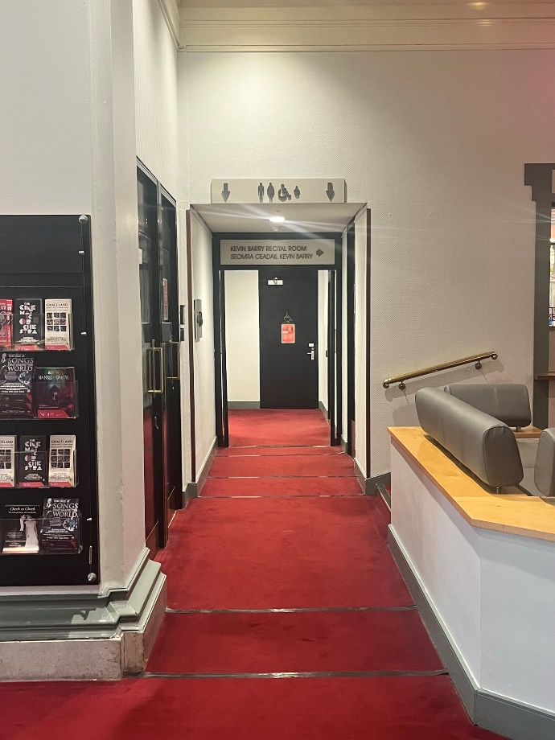 | These toilets can be found beside the box office.
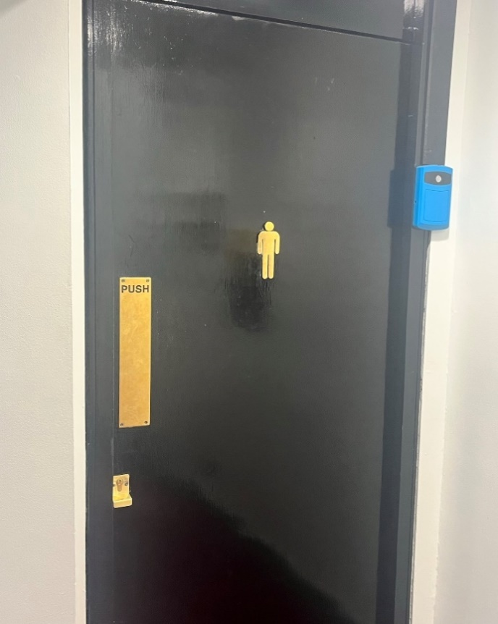 | This is the men’s toilets on the ground floor.
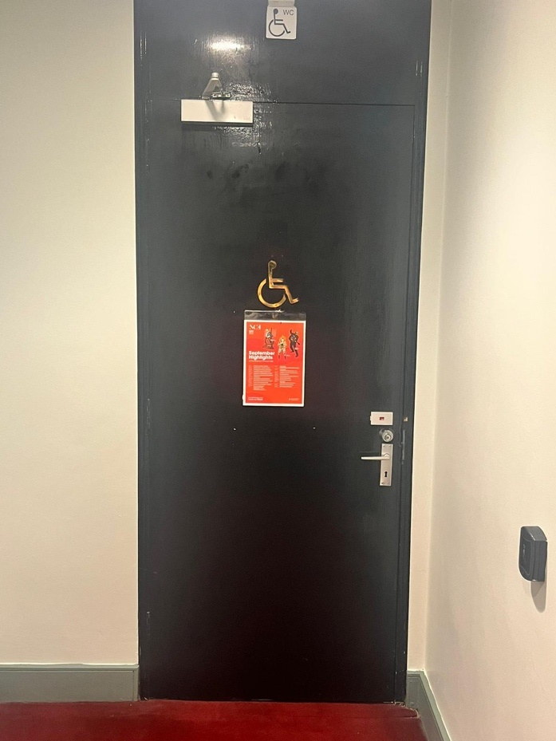 | This is the accessible toilet by the men’s toilet
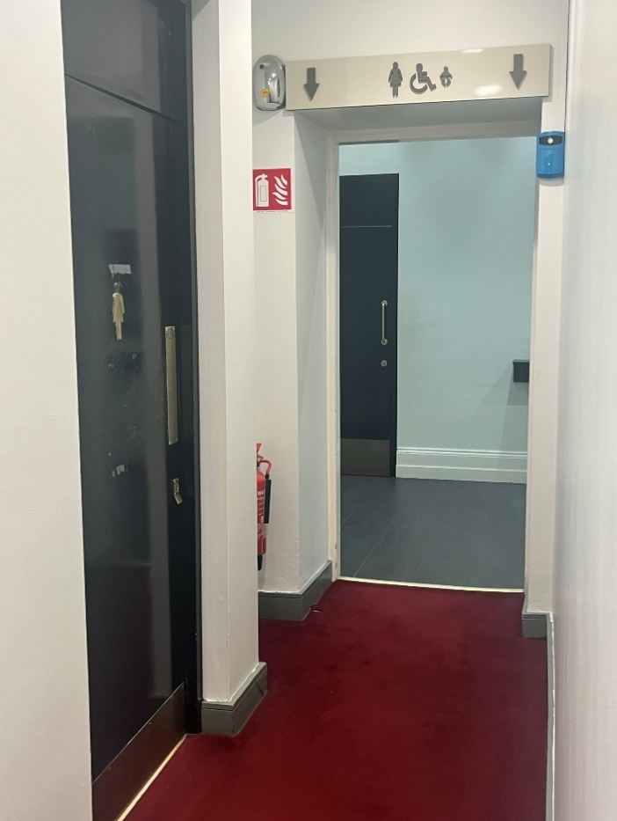 | This is the women’s toilet – there is a second women’s bathroom at the back of the photograph.
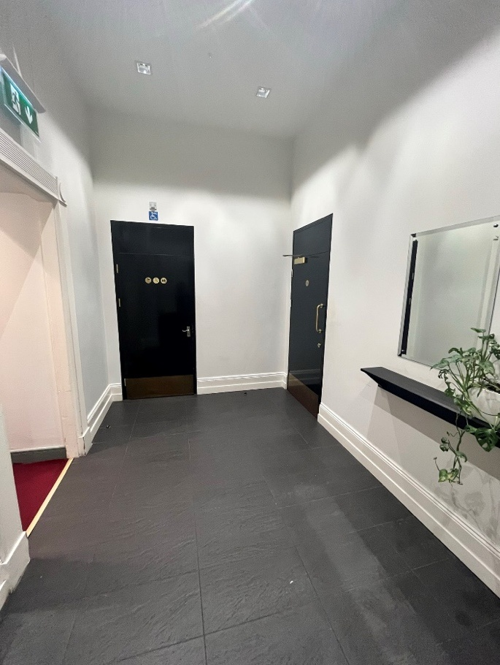 | There is also a second universal access bathroom in this area.
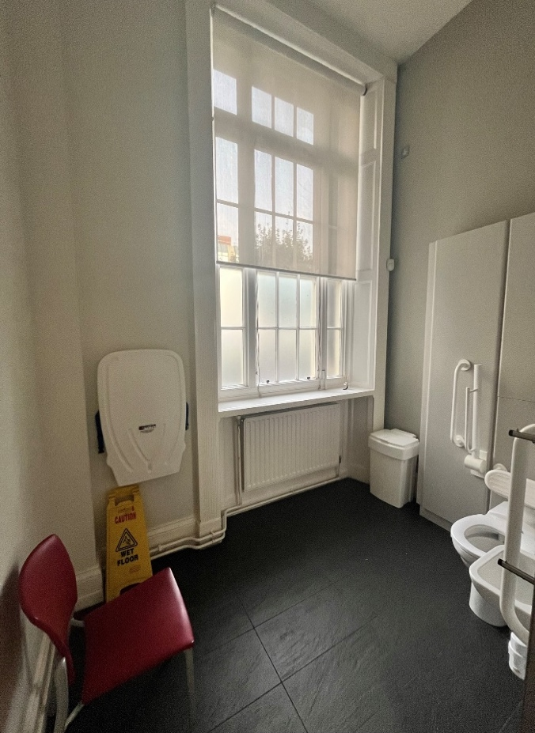 | This is the larger universal access bathroom.

The John Field Room:
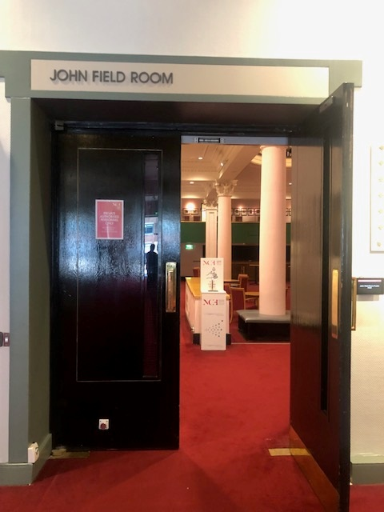 | The concert will take place in the John Field Room on the ground floor.  These are the doors to the John Field Room.  There might be lots of people in here and lots of noise before the concert starts.
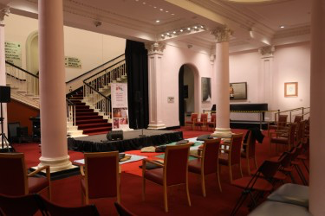 | The room will be set up with chairs.  There will be some space for wheelchair users and wide aisles to move through.  There will be a small stage for the musicians in the room with some chairs, microphones, instruments, speakers and music stands.
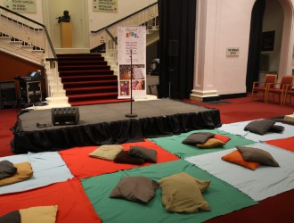 | There will be coloured blankets and cushions laid out in front of the stage, and you can sit on these blankets/cushions, or on the chairs if you prefer.

Soundscapes

At the start of the concert, there will be a short announcement and then the musicians will come onto the stage.

There will be 4 musicians on stage.
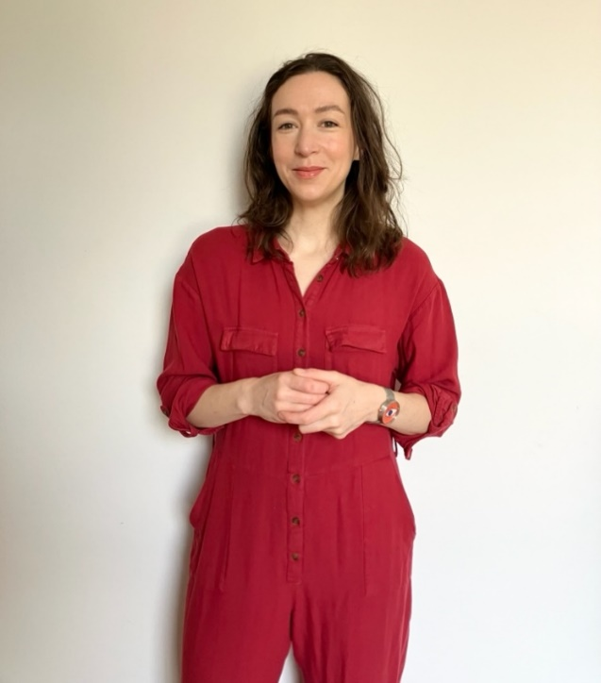 |  | This is Ríona.  Ríona will be singing in today’s concert.  She will be on stage and will also walk amongst the audience with her microphone.  She might ask you your name or ask you to help her to sing a song, but only if you want to!
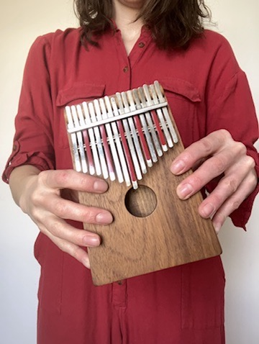 |  | At the beginning of the show Ríona will play a thumb piano.  Audience members will be welcome to try the thumb piano if they wish.
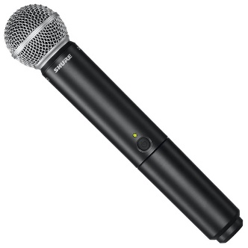 |  | At various point during the show Ríona will sing into a microphone
At another point during the show Ríona will invite audience members to try some other instruments if they wish like;
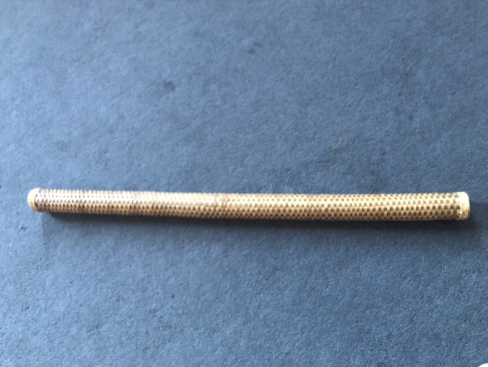 |  | A Rain Stick
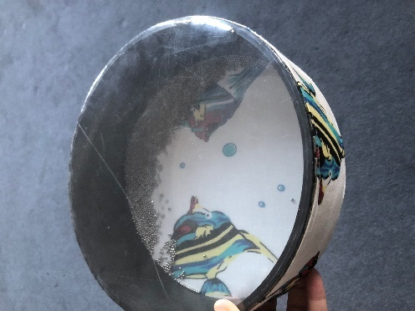 |  | An Ocean Drum
Throughout the show Ríona will use a variety of props to “conduct” the music
-something about the sound of the music will change based on how she, or an audience member, moves this prop.

The audience will be invited to try conducting the music with these props if they wish.
Here are a sample of some of the props used in Soundscapes
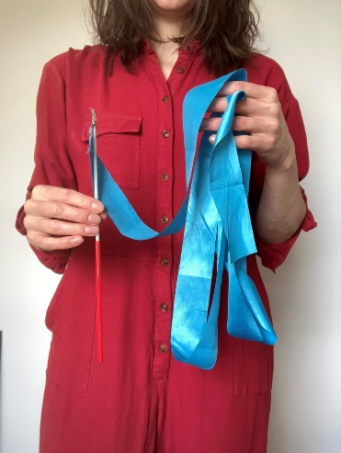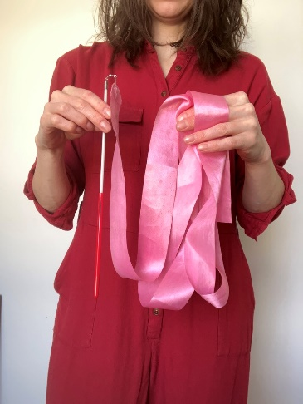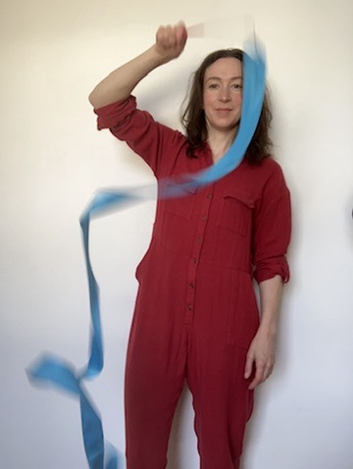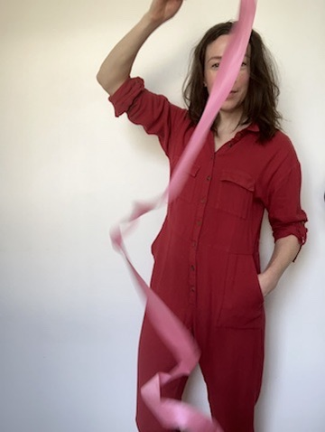 |  | Gymnasts ribbons
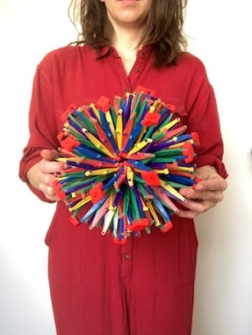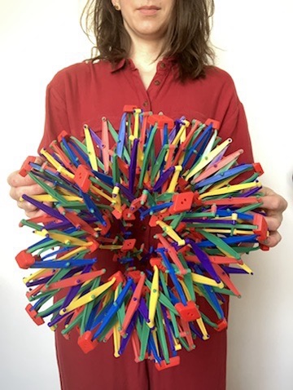  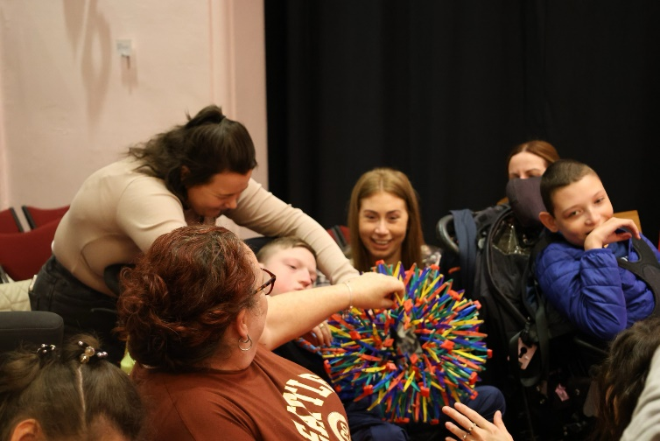 |  | Hoberman sphere  - Ríona will use a hoberman sphere (which looks like a colourful ball) to conduct the dynamics of the music. When the hoberman sphere is opened up and big the music will be louder, when the hoberman sphere is closed and small the music will be quieter  Ríona might invite you to have a turn with the hoberman sphere.
There will be three more performers at Soundscapes.

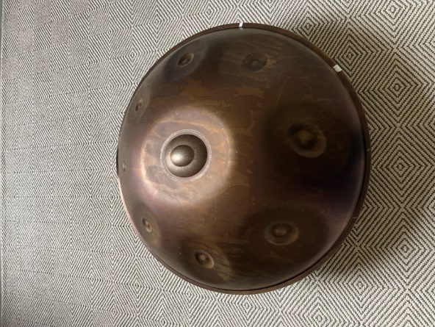 | Eamonn Cagney will play a variety of percussion instruments.  For example a handpan :
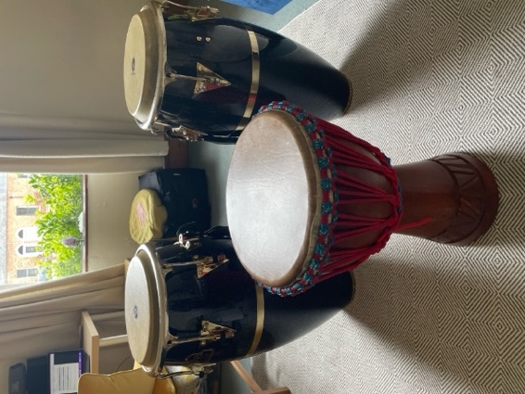 | Eamon will also play congas and a djembe:
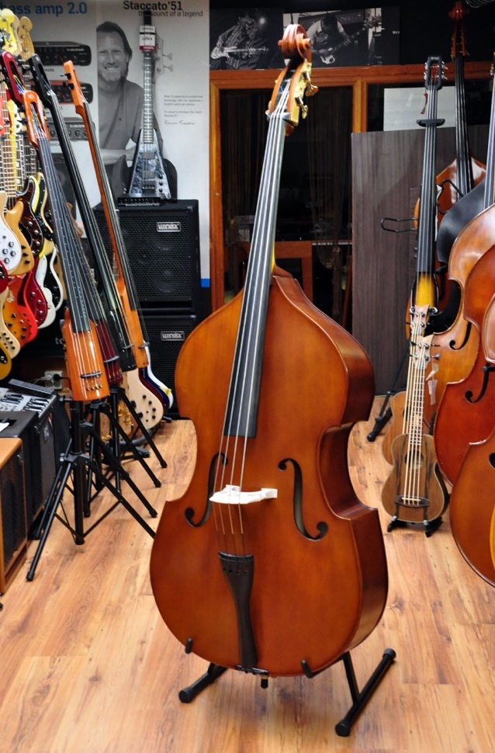 | Aidan Gray will play double bass
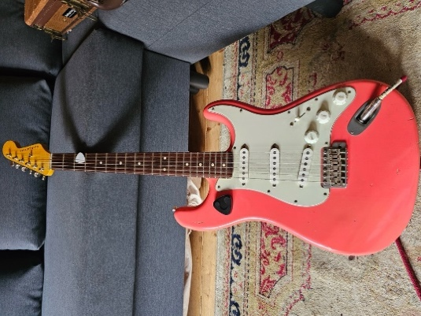 | Max Zaska will play the Guitar
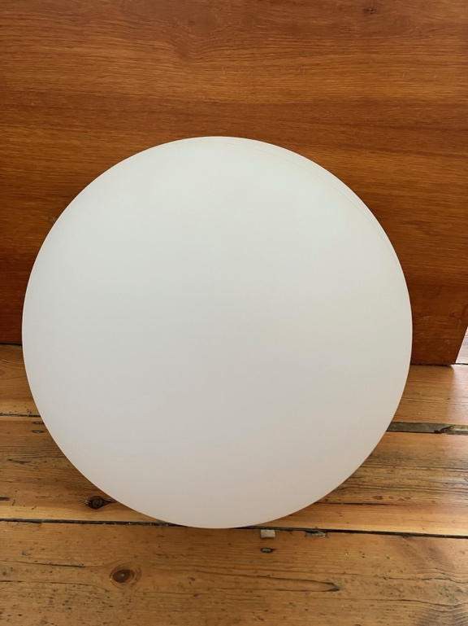  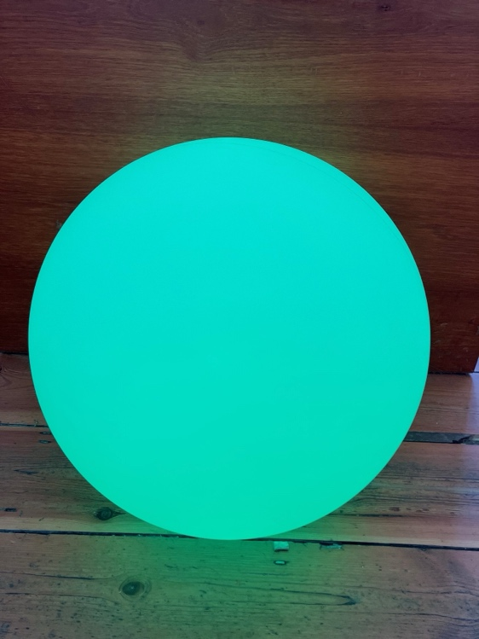  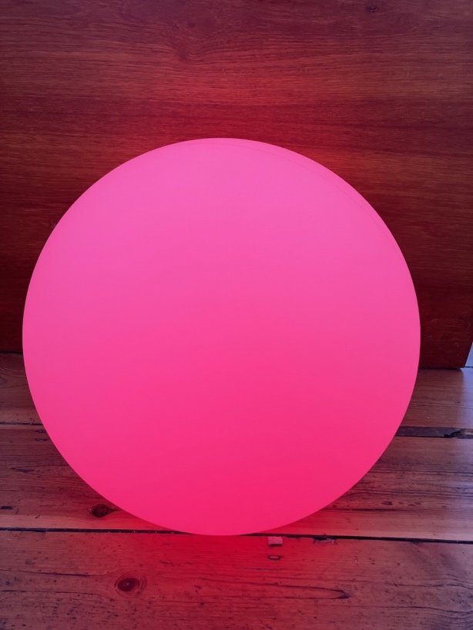 | This light up, colour changing sphere will also be used as a prop in our concert.  Each time the sphere changes colour, the bass player will change the note they are playing.

